Positive Phase 3 Results for Investigational Recombinant Treatment for Hemophilia A and B With Inhibitors
Christina T. Loguidice Published Online: Thursday, Apr 09, 2015

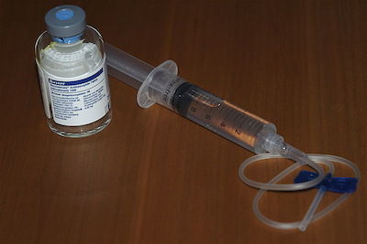

According to the Centers for Disease Control and Prevention, approximately 15% to 20% of patients with hemophilia will develop an inhibitor to the factor clotting concentrates used to treat or prevent bleeding episodes, which is one of the most serious and costly complications of hemophilia.¹ An investigational recombinant factor VIIa treatment known as BAX 817 has recently shown promise in a Phase 3, prospective, open-label, randomized, multicenter trial evaluating its safety and efficacy in patients with hemophilia A or B who have inhibitors.²
The trial included male patients between 12 and 65 years who had hemophilia A or B with inhibitors and were treated over a 6-month period using on-demand therapy with BAX 817. The trial’s primary endpoint was successful resolution of acute bleeding episodes at 12 hours with both assessed on-demand treatment regimens: 90 µg/kg administered three times or 270 µg/kg administered once. Among those receiving three 90 µg/kg doses, 98% achieved resolution at 12 hours compared with 85% of those receiving the 270 µg/kg dose. The overall success rate was 92%, with 89% of patients achieving sustained bleeding control for all acute bleeding episodes 24 hours after infusion.
During the study, no patients developed inhibitors or binding antibodies toBAX 817, but one patient was hospitalized after sustaining a traumatic muscle injury that did not respond to BAX 817. No patients discontinued treatment due to an adverse event, and all nonserious adverse events were attributed to the underlying disease or another etiology, rather than BAX 817.
“The development of inhibitors remains one of the most significant challenges in treating hemophilia, as it may place patients at increased risk for life-threatening complications resulting from difficult-to-treat bleeding episodes,” said John Orloff, MD, vice president and global head of research and development at Baxter BioScience, in a company press release.² “These positive results reflect our commitment to addressing the complex treatment of hemophilia patients with inhibitors, and reinforce our legacy of advancing hemophilia care worldwide,” he added.
Baxter announced that full data from the trial, including additional efficacy and safety outcomes, will be presented at a medical meeting later in 2015, and it plans to initiate regulatory submissions aligned to manufacturing expansions that are already underway.

References

1. Centers for Disease Control and Prevention. Inhibitors.http://www.cdc.gov/ncbddd/hemophilia/inhibitors.html. Updated January 28, 2014. Accessed April 9, 2015.
2. Baxter BioScience announces positive phase III results for BAX 817, investigational recombinant treatment for hemophilia A and B patients with inhibitors [press release]. Deerfield, IL; Baxter; March 13, 2015.http://www.baxter.com/press_room/press_releases/2015/03_13_15_bax817.html. Accessed April 9, 2015.

